Title / Título (IN THE LANGUAGE FROM SUBMISSION)

Autor 1 (Name + Surname)¹*, Autor 2 (Name + Surname) ², Autor 3 (Name + Surname)³,…

¹ Institution 1, Complete address (Street/Avenue, number, district, Zip Code, City, State, Country. E-mail + ORCID
² Institution 2, Complete address (Street/Avenue, number, district, Zip Code, City, State, Country. E-mail + ORCID
³ Institution 3, Complete address (Street/Avenue, number, district, Zip Code, City, State, Country. E-mail + ORCID

Abstract
Write an abstract that is 250 words or less.
Keywords: keyword 1, keyword 2, keyword 3.

Title in Portuguese (if the submission was made in English or Spanish)

Resumo
Digite aqui um resumo com até 250 palavras.
Palavras-chave: palavra 1, palavra 2, palavra 3.

Introduction or Introducción or introdução
Present the subject and cite the Author (e.g. Aguiar & Barciela 1986; Aguiar et al., 2007; Haugaasen et al., 2012; Smith et al., 2014; Duarte et al., 2016; Duarte et al., 2020).
The goals, questions, and hypotheses can all be addressed in the final paragraph.

Material and Methods or Material y Metodos or material e métodoS
Expose all methods and materials used to carry out the study. (Cite the fonts [Authors, Year] following examples in the Introduction).
Inform us if the manuscript was published in a preprint or if the dataset was previously deposited in a database (cite and present the links).

Results or resultados
Present all results. Tables and figures should be called in the text in an abbreviated way (e.g. Tab. 1; Fig. 1 and 2).

Discussion or Discusión or Discussão
Explain the results and demonstrate the advances of the study with basis the others research previous publiblished (Cite the fonts [Authors, Year] following examples in the Introduction).

Conclusion or Conclusiones or conclusões
Based on the findings of the study, objectively respond to the questions and propose in the introduction. It is advised to highlight to the work's significance and explain what generalizations can be drawn from it.

Acknowledgment or Agradecimientos or Agradecimentos
Inform the organizations that provided financial support and the people who helped in the production of the research.

References or Referencias or Referências
Aguiar, F. F. A., M. M. Pinto, A. R. Tavares & S. Kanashiro. 2007. Maturação de frutos de Caesalpinia echinata Lam., pau-brasil. Rev. Árv. 31: 1-6.

Aguiar, I. B. & F. J. P. Barciela. 1986. Maturação de sementes de cabreúva. Rev. Bras. Sem. 8(3): 63-71.

Duarte, E. F., L. S. Funch, R. F. C. Moreira & J. Nakagawa. 2016. Produção de sementes em espécies florestais. pp. 61-102. In: Recursos e estratégias para a restauração florestal: ações para o Recôncavo da Bahia. Cruz das Almas, EDUFRB.

Duarte, E. F., D. S. Almeida, J. A. Santos, C. H. B. Santos, A. D. Azevedo Neto, C. R. P. Cruz & C. P. Peixoto. 2020. Maturação de frutos e sementes de inhaíba (Lecythis lurida [Miers] S. A. Mori - Lecythidaceae). Rev. Biol. Neotrop. / J. Neotrop. Biol. 17(1): 15-34. DOI: https://doi.org/10.5216/rbn.v17i1.57700

Haugaasen, J. M. T., T. Haugaasen, C. A. Peres, R. Gribel & P. Wegge. 2012. Fruit removal and natural seed dispersal of the Brazil Nut tree (Bertholletia excelsa) in central Amazonia, Brazil. Biotropica. 44: 205-210.

Newton, A. C. 2007. Forest ecology and conservation: a handbook of techniques. New York, Oxford University Press.

Smith, N. P., S. A. Mori & G. T. Prance. 2014. Lecythidaceae. Lista de Espécies da Flora do Brasil. Available in: <http://floradobrasil.jbrj.gov.br/jabot/floradobrasil/FB8560>. Accessed on 05 Jun. 2014.

Fig. 1 - Flores, fruto e sementes de inhaíba (Lecythis lurida (Miers) S.A. Mori (Lecythidaceae) ao longo da maturação.
Fig. 1 - Flowers, fruit and seeds of inhaíba (Lecythis lurida (Miers) S.A. Mori (Lecythidaceae) along maturation.

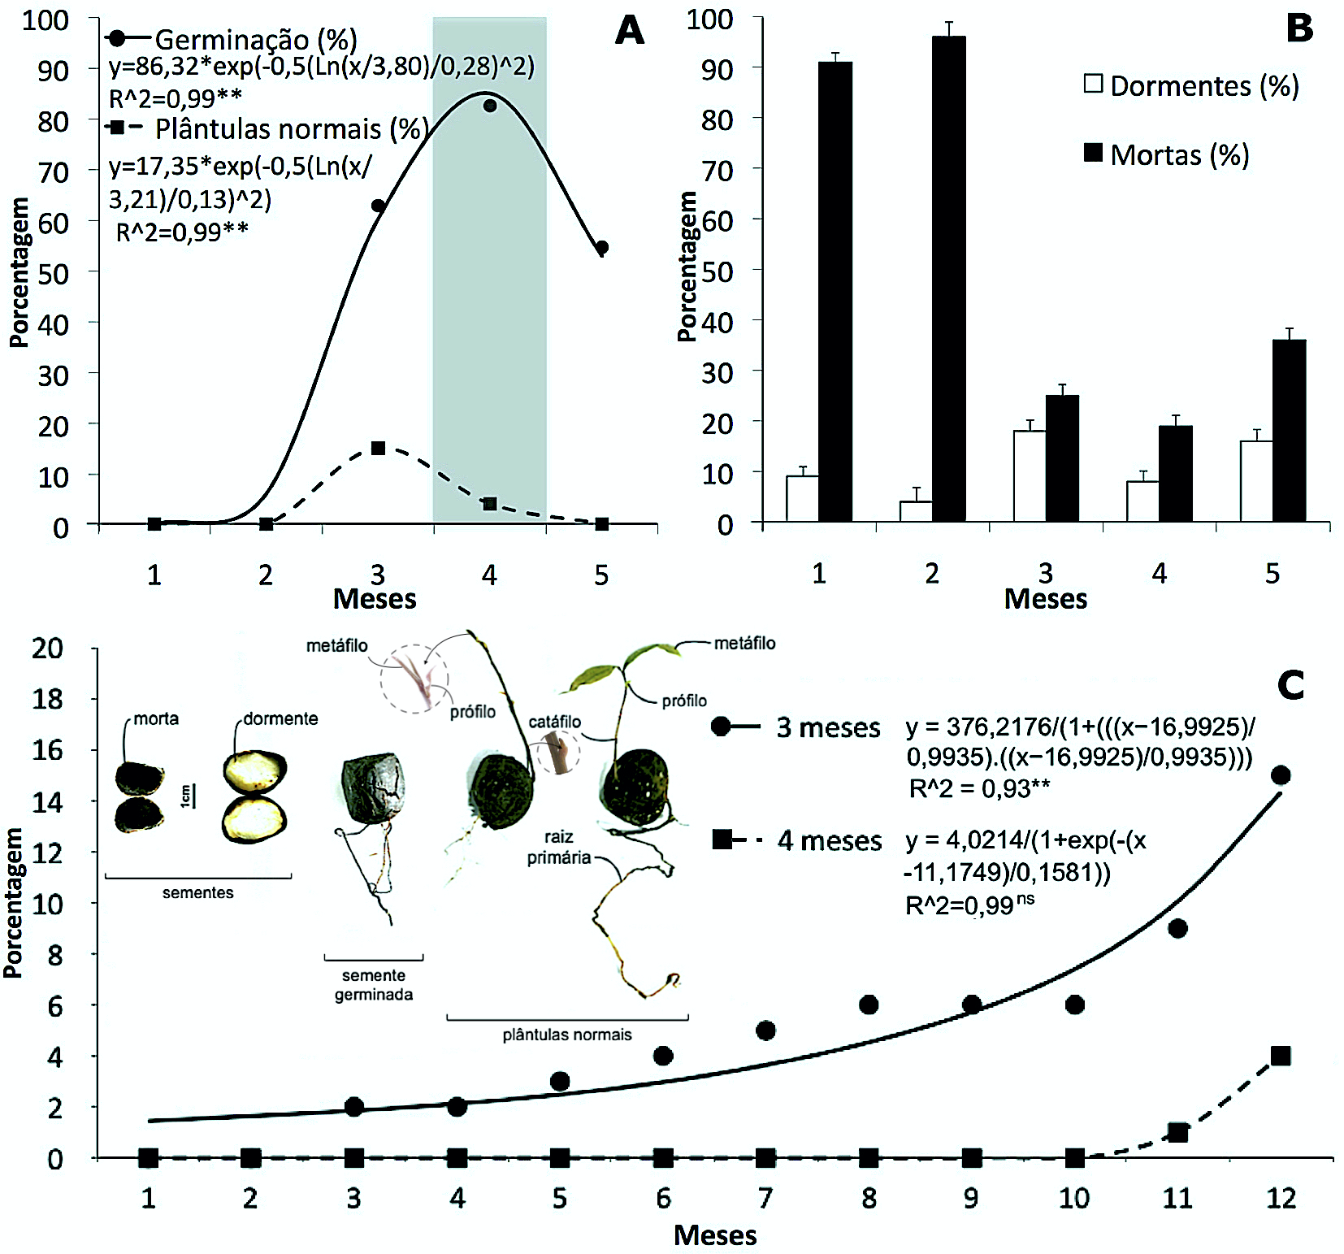
Fig. 2. Germinação e vigor de sementes e plântulas de inhaíba (Lecythis lurida (Miers) S.A. Mori - Lecythidaceae), ao longo da maturação (meses). A. Germinação (%), plântulas normais (%). Área sombreada indica a maturidade fisiológica das sementes; B. dormência (%) e mortalidade (%) de sementes; C. Emergência acumulada de plântulas normais (3 e 4 meses) e imagens ao final de 12 meses. Coeficiente de determinação (R²) seguido por **, indica variação significativa a 1% de probabilidade pelo Teste F. Barras + erro padrão.
Fig. 2. Germination and vigor of the inhaíba (Lecythis lurida (Miers) S.A. Mori - Lecythidaceae) seeds and seedlings along of maturation (months). A. Germination (%), normal seedlings (%). Shadow area indicate seeds physiological maturity. B. Dormancy (%) and mortality (%) of seeds. C. Accumulated emergency of the normal seedlings (3 and 4 months) and images on 12 months. Determination coefficient (R²) followed ** indicate significant variation at 1% of probability, by F Test. Bars + standard error.

